Birla Institute of Technology & Science, Pilani
Work Integrated Learning Programmes Division
Second Semester 2021-2022

Comprehensive Examination
(EC-3 Regular)

Course No. : SS ZG514
Course Title : Object Oriented Analysis and Design
Nature of Exam : Open Book
Weightage : 50%
No. of Pages = 02

No. of Questions = 04
Duration : 2 Hours
Date of Exam : 22/05/2022 (FN)
Note to Students:
- Please follow all the Instructions to Candidates given on the cover page of the answer book.
- All parts of a question should be answered consecutively. Each answer should start from a fresh page.
- Assumptions made if any, should be stated clearly at the beginning of your answer.

- State if the following statements are true or false with appropriate justification in no more than 200 words. (A) A system is designed well if its components are loosely coupled. (B) An Adapter decouples a client from a complex interface. (C) Using the State Pattern results in a lesser number of classes making it easier to maintain and understand the code. [10 Marks]
- Draw a state chart diagram that describes the process of passing a course as a set of concurrent activities. To pass, a student has to attend all but two lectures, present to the class a paper s/he has read, and complete a course project due on the last day of the term. To give his/her presentation, the student is given a date by the instructor, prepares his/her presentation, and gives it on the assigned day. At any time, the student can drop the course. Make sure to define events, conditions, and actions for transitions in your diagram, where appropriate. [10 Marks]
- Solitaire Klondike is a card game in which some cards are placed on the table in a harp shape initially, it is also called tableau (see Figure 1). The remaining cards are placed in a face-down manner in the Deck pile. These cards are turned over one by one and they are either added to the Tableau pile or to the Discard pile. Each card has a rank and a suit. Four suit piles are built during the game (see top right of Figure 1) for each suit. Draw a conceptual class diagram for this game. Show only classes, associations, and multiplicities. Attributes and methods are not required. [10 Marks]

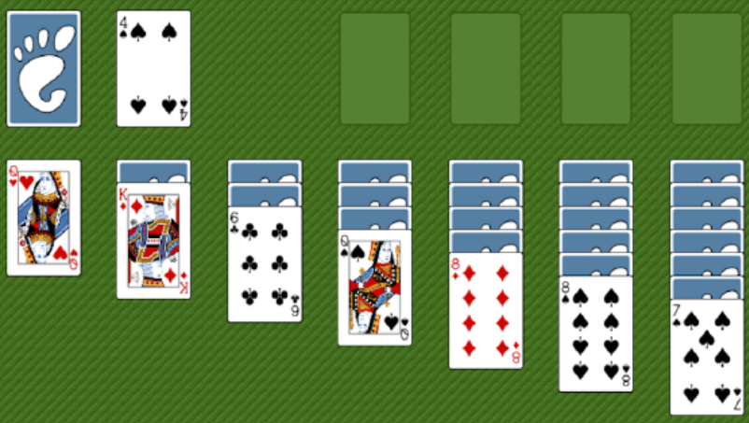
Figure-1: Solitaire Klondike

- We have designed a Minesweeping Robot (MR) for battlefield surveillance that can be teleoperated from a command center. We are required to redesign the control panel of the robot a little bit. The new control panel should provide the following functionality. (A) It should contain a traditional speed meter that shows the current speed of the robot in m/sec. (B) It should contain a digital speed meter that shows the speed of the robot in km/hour. (C) We should be able to regulate the speed of the robot using acceleration and braking pedals. The speed of the robot can also be modified by pushing the cruise control buttons (the “+” button for increasing the speed and the “-” button for decreasing the speed). Select the most appropriate design pattern to use in order to implement the robot control panel (give proper justification for your choice of the design pattern) and show how it is applied. In particular, show an appropriate class diagram.
[20 Marks]

***** Best of Luck *****

